Regenerative Braking Control with Bidirectional Inverter for EV Applications
Hüseyin KURT*
Department of Electrical-Electronics Engineering, Istanbul Aydin University, Istanbul, Turkey
huseyinkurt1@aydin.edu.tr

Abstract
Regenerative braking plays a vital role in electric vehicles (EVs) by enhancing energy efficiency and extending operational range. This study presents a dual-mode regenerative braking control strategy for a permanent magnet synchronous motor (PMSM) drivetrain, integrating a bidirectional buck–boost DC–DC converter with a full-bridge inverter. The bidirectional converter enables efficient bidirectional power flow between the motor and the battery, maximizing energy recovery during braking while ensuring smooth and safe deceleration across varying operating conditions. A field-oriented control (FOC) scheme is implemented for precise torque and flux regulation, and a supervisory logic dynamically selects the converter operating mode based on real-time motor torque feedback. The complete system, including realistic battery dynamics, is modeled and simulated in MATLAB/Simulink under flat-road, low-speed driving conditions. Simulation results show that the proposed method increases recovered energy by more than 22% compared to a conventional unidirectional converter, while maintaining DC bus voltage stability and minimizing torque ripple. These results confirm the practicality of the proposed approach, demonstrating its potential to improve battery state-of-charge (SOC) management, extend EV range, and provide a feasible solution for next-generation regenerative braking systems.
Keywords: Regenerative braking control, bidirectional buck-boost converter, field-oriented control, SVPWM, PMSM, electrical vehicle

1. Introduction
The rising adoption of electric vehicles (EVs) has placed increasing importance on energy efficiency and battery longevity (Chan, 2007; Tie & Tan, 2013). Regenerative braking (RB) has emerged as a key technique for improving energy utilization by recovering kinetic energy during deceleration and storing it back into the battery system (Li, Wang, Li, & Mi, 2016; Jain & Agarwal, 2018). However, conventional RB methods are often limited in low-speed scenarios due to inadequate back-EMF generation (Zhang & Emadi, 2005; Yuan & Zhang, 2019). Permanent Magnet Synchronous Motors (PMSMs) are widely adopted in EV applications due to their high efficiency, power density, and superior torque characteristics (Chau, Chan, & Liu, 2008; Zhu & Howe, 2007). However, the control of PMSMs during regenerative braking introduces several technical challenges, particularly when considering bidirectional energy flow between the battery and motor under dynamic driving conditions (Liu & Mi, 2012; Jain & Shrivastava, 2020). These challenges become more pronounced when the system is expected to switch seamlessly between motoring and regenerative modes without compromising performance or stability (Chien & Chang, 2018). In conventional regenerative systems, a unidirectional control strategy is often employed, which limits the energy recovery potential and fails to optimize the charging dynamics of the battery across road scenarios (Ali & Yousuf, 2019; Jogi & Babu, 2020). To address these limitations, this study proposes a regenerative braking system based on a bidirectional cascaded DC-DC converter interfaced with a full-bridge inverter (Kumar & Jain, 2017). The dual-mode architecture enables two distinct operating strategies: (1) Boost mode during braking, allowing energy recovery by elevating the DC-link voltage for effective battery charging(Zheng & Yu, 2019) and (2) Buck mode during acceleration, facilitating controlled battery discharge for propulsion (Kumar & Singh, 2016). A Field-Oriented Control (FOC) strategy is integrated to ensure precise torque and flux regulation of the PMSM (Ehsani, Gao, Gay, & Emadi, 2005).

2. Methodology
This section presents the modeling, design, and control approach for the regenerative braking system for a PMSM-based electric vehicle at low speed. The MATLAB Simulink simulation model consists of a bidirectional DC-DC converter, an SVPWM inverter for PMSM drive, and FOC algorithm. 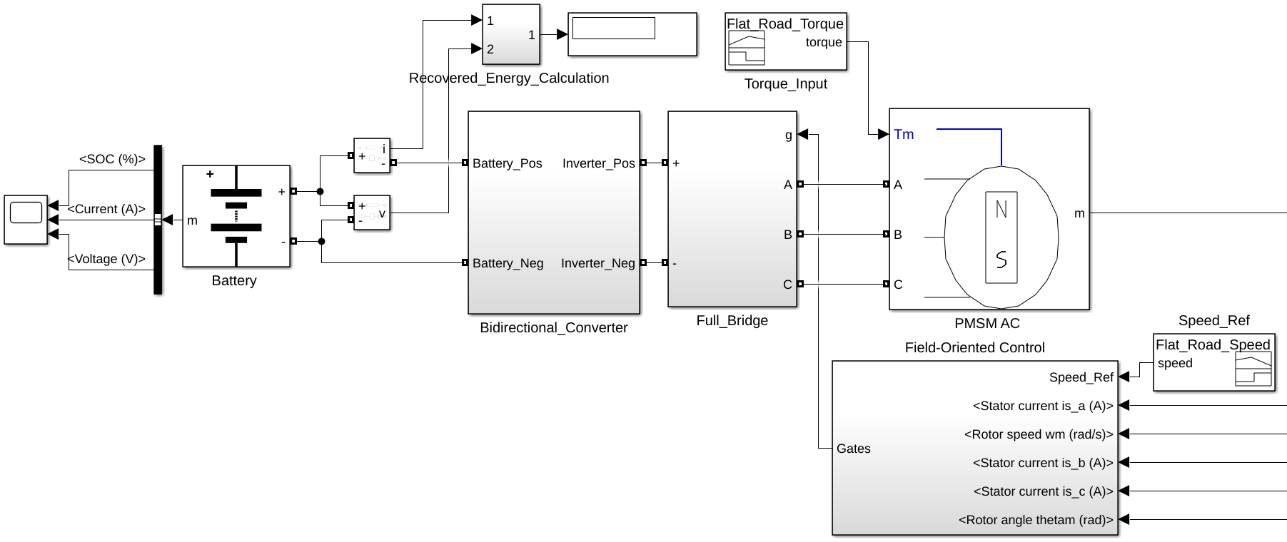
Figure 1. Regenerative braking model blocks.
The components of simulation are; a lithium-ion battery pack serving as the DC energy source and sink, a bidirectional DC-DC converter capable of operating in both buck (regenerating) mode and boost (motoring) mode, a full-bridge inverter for AC excitation of the PMSM, a PMSM as the traction motor.
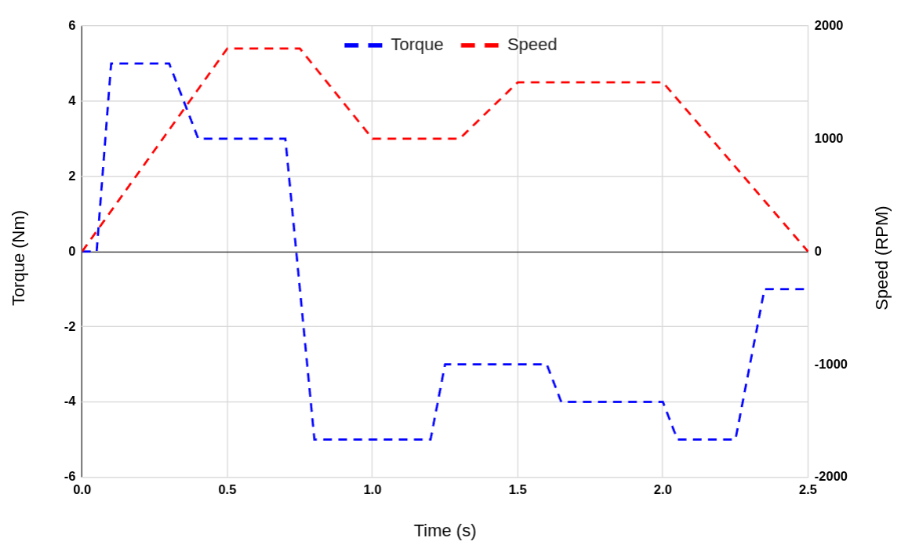
Figure 2: Road torque and reference speed loaded to the PMSM motor.
The reference speed values showing figure 2 are arranged for low speed ($speed<=20 km/h$ ). The torque value is defined for flat road profile.
$Speed (km/h) =\frac{Motor RPM}{Gear Ratio}×π×D_{wheel}×\frac{60}{1000}$ (1)
Where:
- $Motor RPM$ = Motor speed in revolutions per minute
- $Gear Ratio$ = Total reduction (motor turns / wheel turns)
- $D_{wheel}$ = Wheel diameter in meters
- $\frac{60}{1000}$ = ​Converts meters/min to km/h
According to Equation 1, the simulation reference speed ranges from 0 km/h to 20.36 km/h (corresponding to 0 RPM to 1800 RPM).
The PMSM is controlled using the Field-Oriented Control (FOC) technique for both motoring and regenerative modes. The FOC algorithm consists of; Clarke and Park transformations to convert stator currents from three-phase to d-q rotating reference frame, PI controllers for torque and flux control via $i_{d}$ and $i_{q}$​ currents, Space Vector PWM (SVPWM) for inverter switching pattern generation.
Table 1: Parameter of model.
Parameter | Value
Motor nominal voltage | 300 Vdc
PMSM rated power | 2830 W
Converter capacitance | 1000 µF
Converter inductance | 1 mH
Converter switching freq | 5 kHz
Battery nominal voltage | 280 V
Rated capacity (Ah) | 12 Ah
Wheel radius | 0.3 m
Gear ratio | 10

The simulated model parameters are presented in Table 1. The rated values of the selected motor in Simulink are 6 Nm, 300 Vdc, and 4500 RPM. The vehicle has a wheel radius of 0.3 m and a total mass of 1200 kg.

3. Simulation and Results
The proposed model was simulated for a duration of 2.5 seconds. A key innovation of this study is the implementation of a converter control strategy governed by real-time motor torque. The operating modes are defined as follows:
If $T_{e}>0$: Motoring phase → Boost mode,
If $T_{e}<0$: Regenerative braking phase → Buck mode,
Where $T_{e}$ is motor electrical torque.
Buck mode refers to the regenerative phase in which energy flows from the DC link (high voltage) to the battery (low voltage) to charge the battery during braking. The battery voltage, as well as the converter capacitance (C) and inductance (L) values, are calculated for buck mode as follows:
$V_{B}=V_{DC}×D$ (1)
$C=\frac{(1-D)V_{B}}{8LΔV_{B}f}$
$L=\frac{D(V_{DC}-V_{B})}{ΔI_{L}f}$
Boost mode corresponds to the motoring phase, in which energy flows from the battery to the motor. The DC link voltage, capacitance (C), and inductance (L) values for this mode are calculated as follows:
$V_{DC}=\frac{V_{B}}{(1-D)}$
$C=\frac{D×V_{DC}}{R_{out}ΔV_{DC}f}$
$L=\frac{V_{B}×D}{ΔI_{L}f}$, where
The inductance (L) and capacitance (C) are calculated separately for both buck and boost modes. The L and C values of the bidirectional converter are then determined by selecting the maximum calculated values from these two modes. In this study, the key performance indicators (KPIs) monitored include the battery state of charge (SOC), recovered energy, and the system’s speed and torque responses.

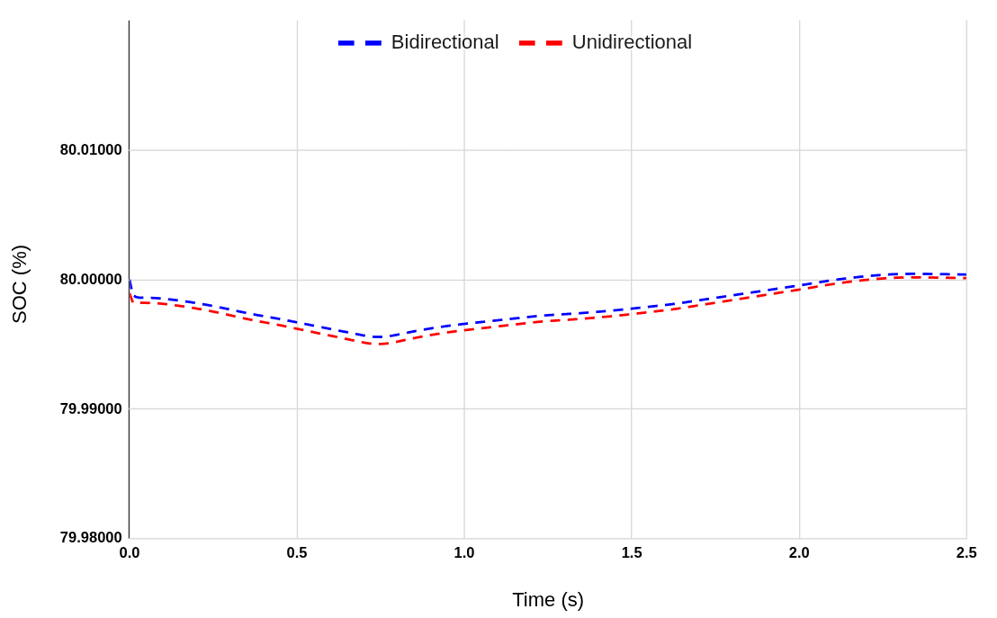
Figure 3 : The proposed system Speed response to.
Both converters are capable of regenerating energy under negative torque; however, the bidirectional converter is significantly more effective than the unidirectional converter in retaining this energy.
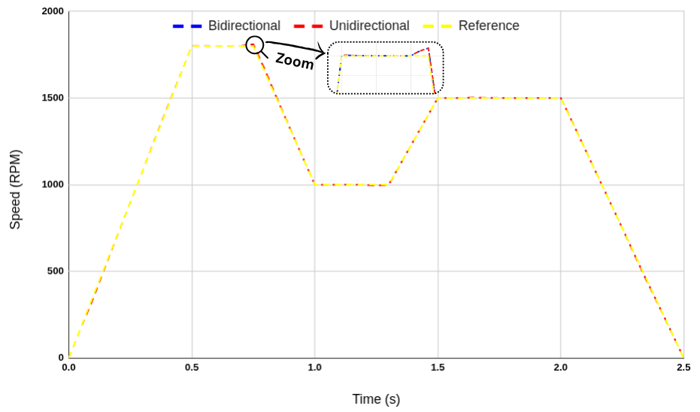
Figure 4 : Reference, unidirectional and bidirectional converter speed responses.
Figure 4 illustrates the speed response of the reference and compared converters under the applied road profile. In both cases, the speed tracking performance is satisfactory, as each converter employs a field-oriented control (FOC) strategy combined with a proportional–integral (PI) controller.
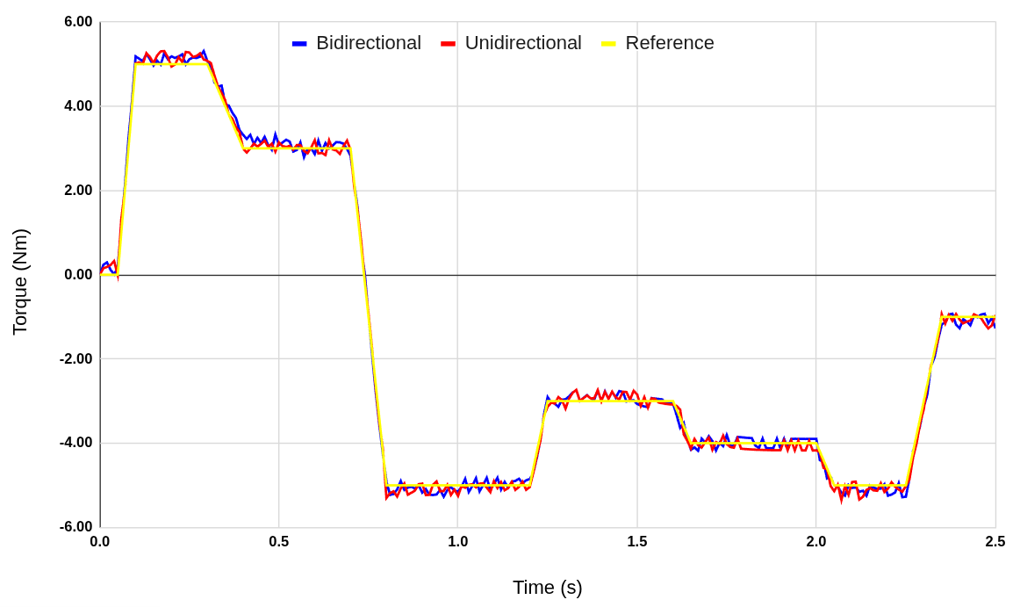
Figure 5: The proposed system Speed response to.
Figure 5 presents the torque response of the two converter types under the applied load profile. During braking, the torque becomes negative, activating boost mode and initiating energy recovery. The smooth transition between acceleration and regenerative braking phases confirms the effectiveness of the dual-mode operation.
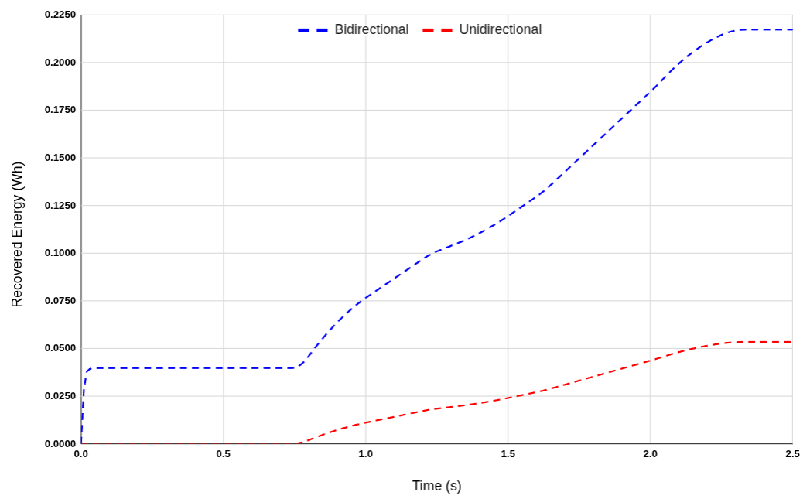
Figure 6: Recovered energy for two converters.
The performance of the proposed bidirectional converter strategy is compared against that of a baseline unidirectional converter.
Table 2: Recovered Energy
Converter Type | Average Regenerative Power (W) | Total Energy Recovered (Wh)
Bidirectional | 312.91 W | 0.2173 Wh
Unidirectional | 256.46 W | 0.1781 Wh

Over a simulation period of 2.5 seconds, the bidirectional converter recovered approximately 0.2173 Wh of energy, compared to 0.1781 Wh recovered by the unidirectional converter. This corresponds to an increase of about 22.01% in recovered energy, demonstrating the superior regenerative capability of the proposed bidirectional converter. These findings validate the effectiveness of the proposed regenerative control strategy. The intelligent mode-switching logic enables efficient energy flow management and ensures seamless operation without introducing torque ripple or system instability. Overall, the results indicate strong potential for real-world implementation, with expected improvements in electric vehicle (EV) range and overall energy efficiency.

Conclusion
This study has presented a dual-mode regenerative braking control strategy for a PMSM-based electric vehicle drivetrain, employing a bidirectional cascaded DC–DC converter. By integrating this converter topology with a field-oriented control (FOC) scheme, the system achieves efficient bidirectional power flow management between the motor and the battery.
Simulation results, validated under flat-road, low-speed driving scenarios, demonstrated that the proposed approach offers superior energy recovery performance. Compared to conventional unidirectional converter-based regenerative braking systems, the bidirectional converter strategy increased recovered energy by more than 22.01%, while ensuring system stability, effective DC bus voltage regulation, and smooth torque transitions.
The successful implementation of the dual-mode converter logic in MATLAB/Simulink confirms the practicality of this architecture for real-world electric vehicle applications. Beyond enhancing energy efficiency and battery state-of-charge (SOC) management, the proposed method has the potential to extend the operational range of electric vehicles without introducing significant system complexity, thereby offering a promising solution for next-generation EV drivetrain designs.

References
Chan, C. C. (2007). The state of the art of electric, hybrid, and fuel cell vehicles. Proceedings of the IEEE, 95(4), 704–718. https://doi.org/10.1109/JPROC.2007.892489
Ehsani, M., Gao, Y., Gay, S. E., & Emadi, A. (2005). Modern electric, hybrid electric, and fuel cell vehicles: Fundamentals, theory, and design (2nd ed.). CRC Press.
Liu, J., & Mi, C. C. (2012). Power electronics for electric vehicles and hybrid electric vehicles. Wiley-IEEE Press.
Chau, K. T., Chan, C. C., & Liu, C. (2008). Overview of permanent-magnet brushless drives for electric and hybrid electric vehicles. IEEE Transactions on Industrial Electronics, 55(6), 2246–2257. https://doi.org/10.1109/TIE.2008.921602
Tie, S. F., & Tan, C. W. (2013). A review of energy sources and energy management system in electric vehicles. Renewable and Sustainable Energy Reviews, 20, 82–102. https://doi.org/10.1016/j.rser.2012.11.077
Ali, S., & Yousuf, M. (2019). Comparative analysis of regenerative braking systems. Energy Reports, 5, 1413–1423. https://doi.org/10.1016/j.egyr.2019.09.010
Li, L., Wang, Y., Li, J., & Mi, C. C. (2016). Online optimal control of regenerative braking for electric vehicles. IEEE Transactions on Vehicular Technology, 65(7), 5439–5448. https://doi.org/10.1109/TVT.2015.2475741
Zhang, Y., & Emadi, A. (2005). Impact of regenerative braking on vehicle performance—Comparative analysis of different electric propulsion systems. IEEE Transactions on Vehicular Technology, 54(6), 1613–1619. https://doi.org/10.1109/TVT.2005.858010
Yuan, W., & Zhang, H. (2019). Bidirectional DC–DC converter design for regenerative braking energy recovery. Journal of Power Electronics, 19(5), 1336–1345.
Jain, P., & Agarwal, A. (2018). Regenerative braking in electric vehicles using bidirectional DC-DC converter: A review. International Journal of Power Electronics and Drive Systems, 9(4), 1860–1871.
Jogi, A. V., & Babu, T. R. (2020). A review on bidirectional DC–DC converters for regenerative braking in electric vehicles. International Journal of Electrical and Computer Engineering, 10(5), 5015–5022.
Zhu, Z. Q., & Howe, D. (2007). Electrical machines and drives for electric, hybrid, and fuel cell vehicles. Proceedings of the IEEE, 95(4), 746–765. https://doi.org/10.1109/JPROC.2007.892482
Kumar, N., & Jain, A. (2017). Dual-mode DC–DC converter with regenerative braking for electric vehicle applications. International Journal of Electronics, 104(8), 1366–1382.
Jain, R., & Shrivastava, V. (2020). Regenerative braking system using fuzzy logic controller for electric vehicle. International Journal of Intelligent Engineering and Systems, 13(3), 221–230.
Chien, T. H., & Chang, C. C. (2018). Adaptive regenerative braking control strategy for electric vehicles. International Journal of Automotive Technology, 19(3), 457–464.
Kumar, R., & Singh, B. (2016). Power quality improvement in electric vehicle using bidirectional converter. IEEE Transactions on Industrial Applications, 52(5), 4137–4145.
Zheng, Y., & Yu, H. (2019). Control of electric braking torque for regenerative braking systems. IEEE Access, 7, 130984–130992. https://doi.org/10.1109/ACCESS.2019.2939914

